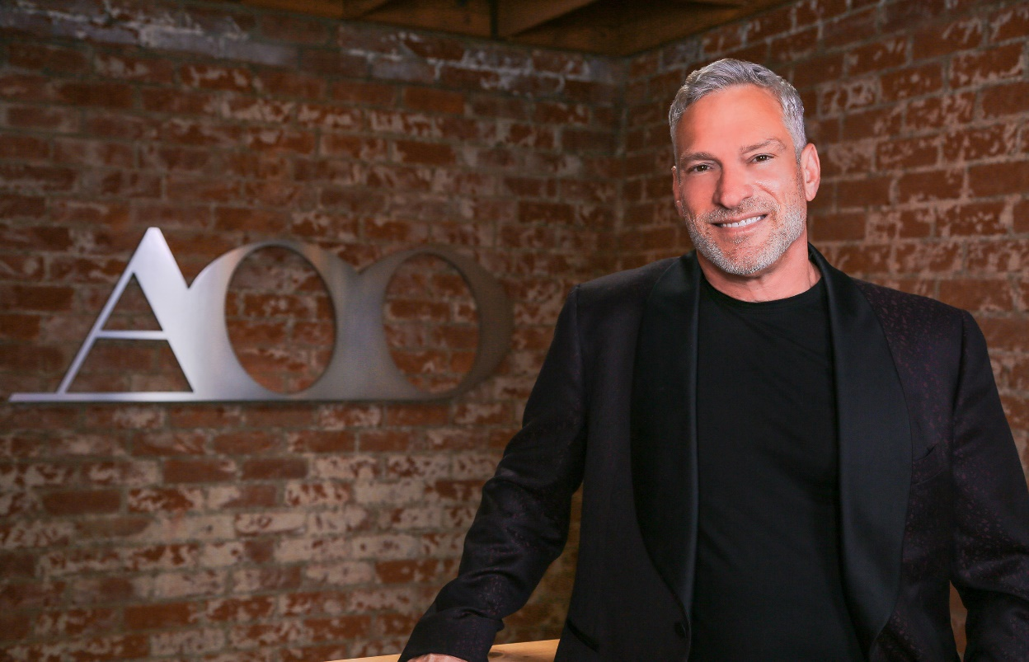

David E. Merrell CEO/Creative Director AOO Events

Since founding AOO Events, Inc. in 1989, David Merrell’s name has become synonymous with cutting-edge event design and production.

David and his team at AOO have been honored by a wide range of professional organizations with more than 25 International awards in a wide range of categories, a testament to the diversity and talent within his company. David himself was named Designer of the Year by Event Solutions Magazine and has taken home the prestigious Crystal Site Award from the Society of Incentive and Travel Executives. David was most recently awarded the Klaus Inkamp Lifetime Achievement Award for 2017 by the International Live Events Association (ILEA) and the 2019 Steve Kemble Leadership Award.

He has served on the ILEA board as president of the Greater Los Angeles Chapter and currently sits on the Advisory Board of Catersource and BizBash.

Continuously leading the market in a forward direction with authoritative momentum, David E. Merrell and AOO Events can respectively be considered a driving force in today’s event industry.

